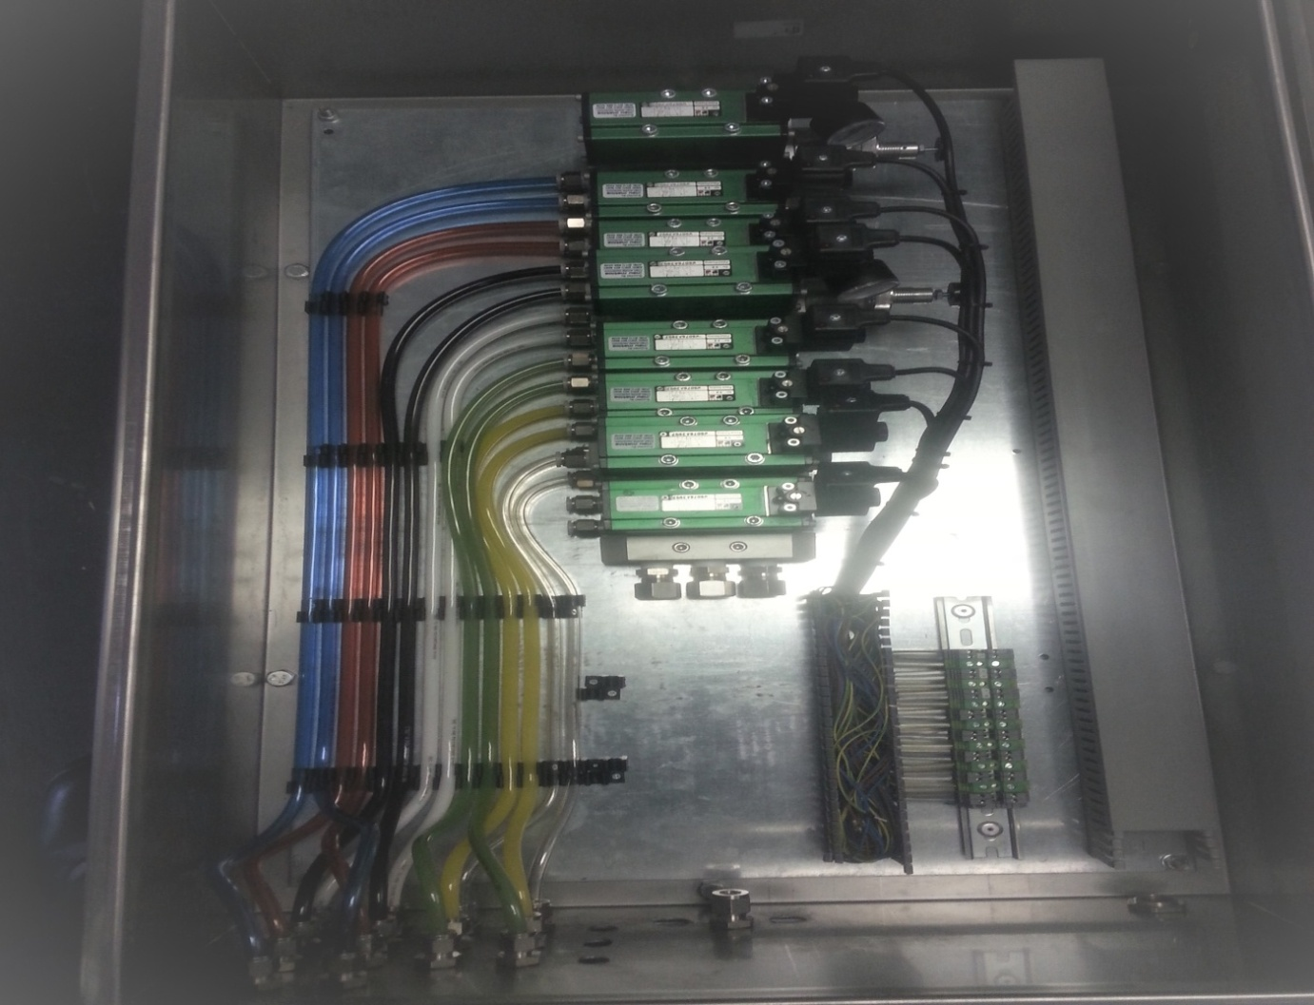

**BUILT PANELS FOR ILLOVO UMZIMKULLU , I ALSO DID THE STAINLESS TUBING TO LINK FIELD**

**HANNES - 08**

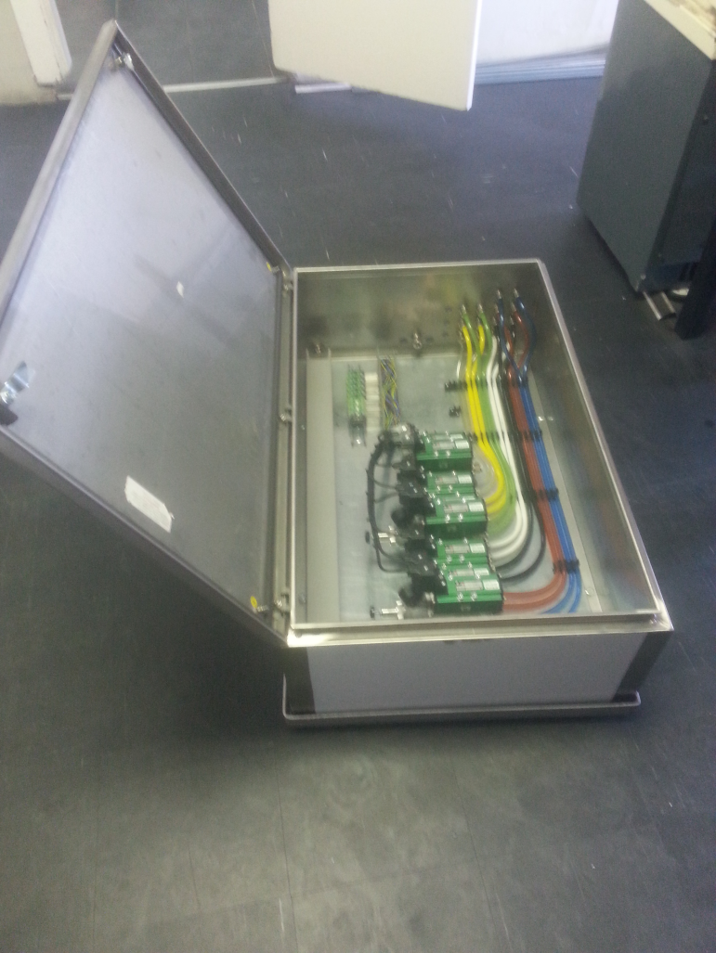

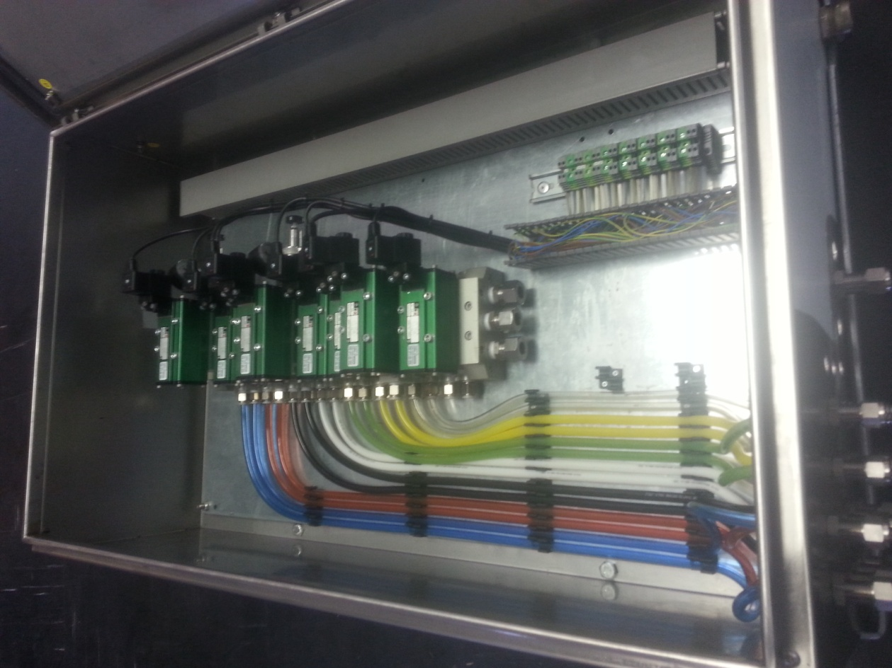

ILLOVO UMZIMKULLU PANELS – HANNES -08

